**THE IMPACT AND AFTERMATH OF PHILIP’S ASSASSINATION**

(BRADLEY, PP 2014-2016)

**Revision**

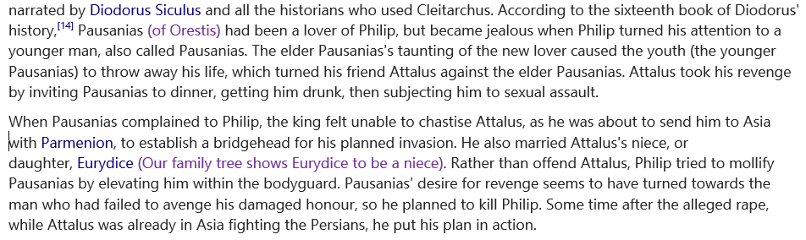

**Watch the clip RE the assassination of Philip II.** <https://www.youtube.com/watch?v=SoCfJHIAjLo>

**Now, read Diodorus’ account of the assassination.**

**16.94** [1] Pausanias preserved his anger, just as it had been, and was keen not only to avenge himself on the one who had wronged him [**but also on the king**](https://johndclare.net/AncientHistory/Alexander_Sources2.html)who had failed to grant him revenge. He was supported in this plan by [**the sophist Hermocrates**](https://johndclare.net/AncientHistory/Alexander_Sources2.html); he had been a pupil of this man, and during his studies had asked how a man might become most famous. Hermocrates replied that he might achieve this if he killed the man who had achieved the greatest deeds, as the killer of such a man would be remembered together with the man he killed.  
  
[2] Pausanias applied this saying to his personal anger, and, [**allowing no postponement of his plan**](https://johndclare.net/AncientHistory/Alexander_Sources2.html)because of his sense of being wronged, put his plan into action during this festival in the following manner.  
  
[3] He positioned [**horses**](https://johndclare.net/AncientHistory/Alexander_Sources2.html)by the gates to the city and went to the entrance of the theatre with a [**Celtic**](https://johndclare.net/AncientHistory/Alexander_Sources2.html)dagger hidden from view. When Philip told those friends who were accompanying him to go into the theatre before he did, the bodyguards kept their distance, then Pausanias, seeing that the king was alone, ran up to him and striking him straight through the ribs left him dead on the ground; then he sprinted for the gates and the horses he had readied for flight.  
  
[4] At once some of the bodyguards rushed to the body of the king, while the others poured out in pursuit of the killer: in this group were [**Leonnatus and Perdiccas and Attalus**](https://johndclare.net/AncientHistory/Alexander_Sources2.html). Pausanias had a head start and would have leapt onto a horse before they reached him, if he had not caught his boot on a vine and fallen. Because of this, the men with Perdiccas caught up with him as he was getting up from the ground and killed him with their spears.

**Putting Diodorus’ potential bias aside for now, how successful was the co-writer and director, Oliver Stone, historiographically speaking?**

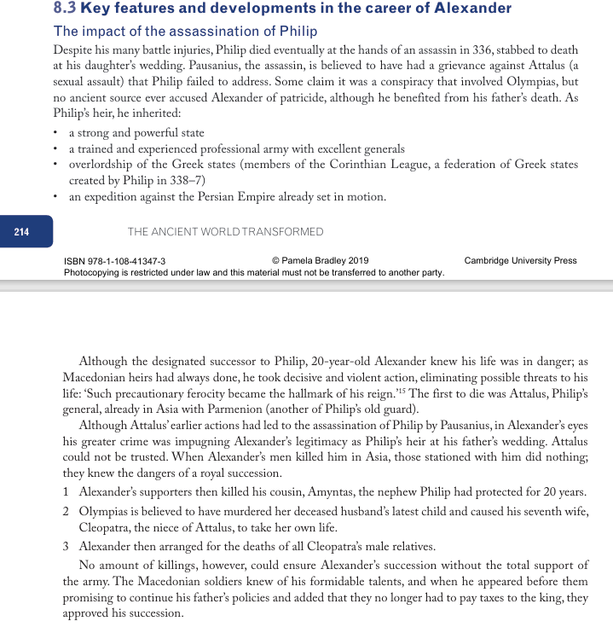



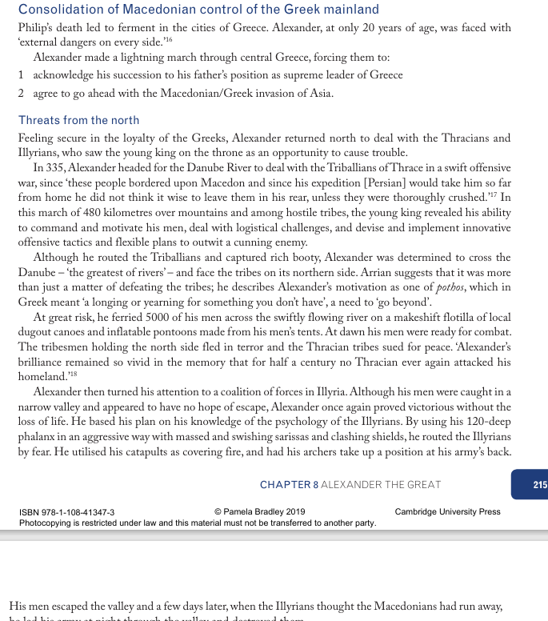



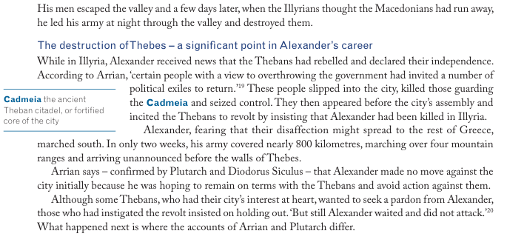

**WHAT CAN WE LEARN FROM THE DESTRUCTION OF THEBES?**

**Alexander’s ‘precautionary ferocity’**

**frightening the rest of Greece into submission**



**From Pamela Bradley, the Ancient World Transformed**

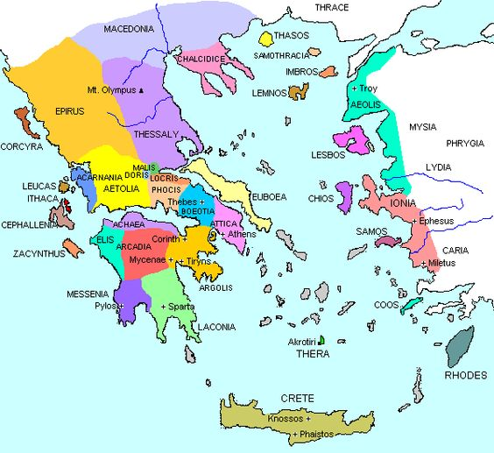

**In 2005, American classics historian and professor Christopher W. Blackwell, wrote this:**

Our understanding of how the Greeks viewed this treaty [*what is called The Common Peace between Philip and the Greek states – one in which he dominated*] must take into account the widespread rebellion against Macedonian hegemony that immediately followed Philip’s death, and the complete destruction of Thebes that was Alexander’s reaction. As soon as Philip was assassinated, in 336 BC, the **Athenians, Aetolians, Ambraciots, Thebans, Eleians**, **and *Messenians* immediately tried to do away with any Macedonian controls** (Diod. 17.3.1-5; Dem. 16.4, 7; Plut. Dem. 22.2). But Alexander seems to have coveted his father’s office … and when he had secured his position in Macedon, had waged a swift war against his enemies to the north, and had marched south with an army to deal with the rebellious Thebans, he met with the **Thessalian league** and the **Amphictyons**, both of whom “he persuaded to give him hegemony of the Greeks by a common decree” … (Diod. 17.4.1-3; Arrian 1.1.2; also, Justin 11.2.5). Alexander defeated Thebes, but left its fate ostensibly in the hands of the [conference](http://www.perseus.tufts.edu/cgi-bin/morphindex?lang=greek&lookup=sune/drion), which obliged him by voting the utter destruction of the city [at least, according to Diod. 17.14.1]. Having destroyed Thebes and enslaved some 30,000 of its citizens, he was in a position to demand all the titles and honors granted his father.

Again, there was a meeting at Corinth, and again the delegates elected the Macedonian ruler general emperor of Greece (Diod. 17.4.9). After presenting the Greeks with this object lesson, Alexander crossed to Asia and presumably delegated at least the day-to-day affairs of Macedonian hegemony in Europe to Antipater.

The destruction of Thebes shows more clearly than anything else the extent to which the Common Peace was, for all its egalitarian terminology, forced upon an unenthusiastic Greece. The Greeks threw off the trappings of a Macedonian-imposed order as soon as it seemed Philip could no longer enforce it, and resumed them only in the presence of Alexander and his army.

**Q1. What does Blackwell (above) suggest was Alexander’s primary motive in destroying Thebes?**

**See the excerpt from Arrian’s Anabasis** **on the next page.**

Arrian was a Roman military author who wrote extensively on Alexander in the 1st and 2nd CE.

**Q2. What is an anabasis?**

**Q3. What did Arrian have to say about Alexander prior to the attack on Thebes? How do his words, here, align with his general feelings about Alexander?**

**Q4. What did Diodorus Siculus have to say about Alexander prior to the attack on Thebes? How do the accounts of Alexander prior to the attack vary between Arrian and Diodorus, and how might you account for that difference?**

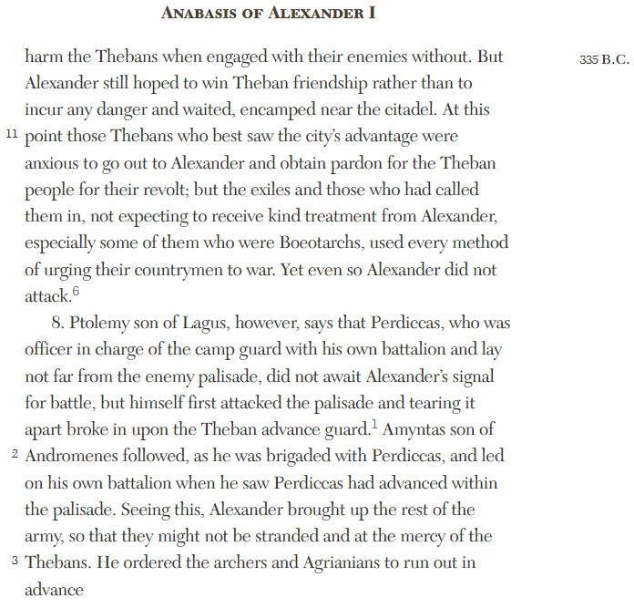

***Before* the sack of Thebes according to Diodorus Siculus**

9 1 So when the king appeared suddenly out of Thrace with all his army, the alliances of the Thebans had furnished them with only a hesitant support while the power of their opponents possessed an obvious and evident superiority. Nevertheless, their leaders assembled in council and prepared a resolution about the war; they were unanimous in deciding to fight it out for their political freedom. The measure was passed by the assembly, and with great enthusiasm all were ready to see the thing through.

2 At first the king made no move, giving the Thebans time to think things over and supposing that a single city would never dare to match forces with such an army. 3 For at that time Alexander had more than thirty thousand infantry and no less than three thousand cavalry, all battle-seasoned veterans of Philip's campaigns who had hardly experienced a single reverse. This was the army on the skill and loyalty of which he relied to overthrow the Persian empire. 4 If the Thebans had yielded to the situation and had asked the Macedonians for peace and an alliance, the king would have accepted their proposals with pleasure and would have conceded everything they asked, for he was eager to be rid of these disturbances in Greece so that he might without distraction pursue the war with Persia.

Finally, however, he realized that he was despised by the Thebans, and so decided to destroy the city utterly and by this act of terror take the heart out of anyone else who might venture to rise against him. 5 He made his forces ready for battle, then announced through a herald that any of the Thebans who wished might come to him and enjoy the peace which was common to all the Greeks. In response, **the Thebans with equal spirit proclaimed from a high tower that anyone who wished to join the Great King and Thebes in freeing the Greeks​ and destroying the tyrant of Greece should come over to them.** 6 This epithet stung Alexander. He flew into a towering rage and declared that he would pursue the Thebans with the extremity of punishment. Raging in his heart, he set to constructing siege engines and to preparing whatever else was necessary for the attack.

**The sack of Thebes according to Diodorus Siculus**

[17.11.1] Now the king in the course of only three days made everything ready for the assault. He divided his forces into three parts and ordered one to attack the palisades which had been erected before the city, the second to face the [Theban](https://www.livius.org/articles/place/thebes-greece/) battle line, and the third as a reserve to support any hard pressed unit of his forces and to enter the battle in its turn.

[17.12.1] At length [Alexander](https://www.livius.org/articles/person/alexander-the-great/) saw that the Thebans were still fighting unflinchingly for their freedom, but that his Macedonians were wearying in the battle, and ordered his reserve division to enter the struggle. As this suddenly struck the tired Thebans, it bore heavily against them and killed many.

[17.12.2] Still the Thebans did not concede the victory, but on the contrary, inspired by the will to win, despised all dangers. They had the courage to shout that the Macedonians now openly confessed to being their inferiors. Under normal circumstances, when an enemy attacks in relays, it is usual for soldiers to fear the fresh strength of the reinforcements, but the Thebans alone then faced their dangers ever more boldly, as the enemy sent against them new troops for those whose strength flagged with weariness.

**(and later)**

[17.13.1] So while the city was being taken, many and varied were the scenes of destruction within the walls. Enraged by the arrogance of the Theban proclamation, the Macedonians pressed upon them more furiously than is usual in war, and shrieking curses flung themselves on the wretched people, slaying all whom they met without sparing any.

[17.13.2] The Thebans, for their part, clinging desperately to their forlorn hope of victory, counted their lives as nothing and when they met a foeman, grappled with him and drew his blows upon themselves. In the capture of the city, no Theban was seen begging the Macedonians to spare his life, nor did they in ignoble fashion fall and cling to the knees of their conqueror

[17.13.3] But neither did the agony of courage elicit pity from the foe nor did the day's length suffice for the cruelty of their vengeance. All the city was pillaged. Everywhere boys and girls were dragged into captivity as they wailed piteously the names of their mothers. In sum, households were seized with all their members, and the city's enslavement was complete…

[17.13.5] As the slaughter mounted and every corner of the city was piled high with corpses, no one could have failed to pity the plight of the unfortunates. For even Greeks - Thespians, Plataeans and Orchomenians and some others hostile to the Thebans who had joined the king in the campaign - invaded the city along with him and now demonstrated their own hatred amid the calamities of the unfortunate victims.

[17.13.6] So it was that many terrible things befell the city. Greeks were mercilessly slain by Greeks, relatives were butchered by their own relatives, and even a common dialect induced no pity. In the end, when night finally intervened, the houses had been plundered and children and women and aged persons who had fled into the temples were torn from sanctuary and subjected to outrage without limit.

[17.14.1a] Over six thousand Thebans perished, more than thirty thousand were captured, and the amount of property plundered was unbelievable. The king gave burial to the Macedonian dead, more than five hundred in number.

**GO TO YOUR A3 ANCIENT VOICES SUMMARY**

|  |  |
| --- | --- |
| **Ancient Voices – Perspectives on Alexander III** | |
| **ARISTOBULUS** | **ARRIAN** |
| **DIODORUS SICULUS** | **PLUTARCH** |

**OPTIONAL reading for your essay prep**

You might want to use information from this table later (it is in our textbook) if you find yourself discussing Thebes and the motives for the destruction as described by different ancient authors.

